ITERATIONS TO FIX – ANTIGRAVITY
- Command Center:  fix UI to have it be in one line
- Command Center: Change “current arc” to “current location in world”
  - Then below add “current mission/quest”
- Next Session Preview Box: 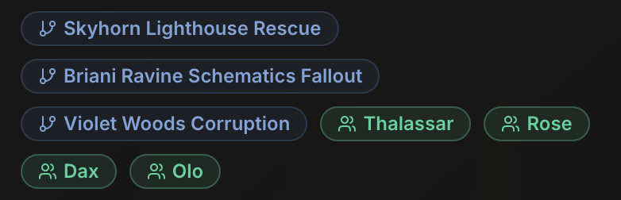make into separate sections, one with list of involved NPCs other with colliding storylines
  - remove
- Session Planner:change message icon to location icon
- Egan:
  - Add an in-app word processor, replacing google docs. The DM writes messy notes, then press “Sync”. Agent analyzes the doc, and provides a list of proposed changes for each tab (like a Pull Request), where agents can amend or “merge”.
    - Folder/file structure:
      - Folder: Magic Items Wishlists
        - Docs:
          - Character A Wishlist
          - Character B Wishlist
          - …
          - Magic Items
        - Feature:
          - Add new wishlist doc per character
      - Folder: Character backgrounds
        - Doc: Character Template
        - Doc: Character A Background
        - Doc: Character B Background
        - Doc: Character … background
        - Feature:
          - Add new wishlist doc per character
      - Folder: Session Outlines
        - Docs
          - Doc: Session 1
          - Doc: Session 2
          - Doc: Session 3
          - …
        - Feature: Ability to add new sessions
      - Doc: Party Notes
      - Doc: Party Goals
      - Doc: NPC Tracker
      - Doc: Midnight thoughts
        - Where DM can ramble any random messy data
- Add a new In-game voice transcript tab
- Session 3 Preview Box in Session Planner: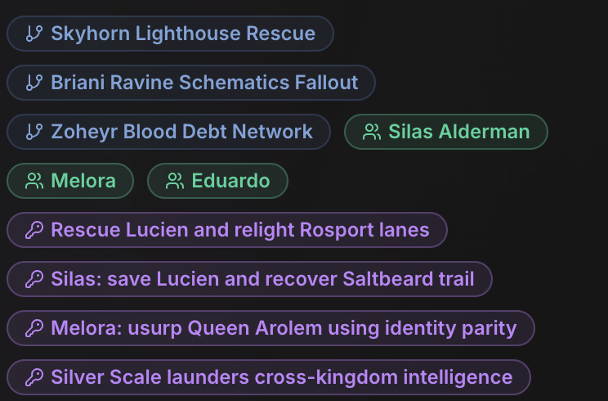separate and label “plot lines”, “NPCs”, “missions”, and “secrets”
  - Change “key beats” to “Act” + 1,2,3,...
    - Under each Act have description of scenery, story context, description of NPCs, encounters, places they will visit, relevant skill checks, and most importantly suggested dialogue
  - Have locations link to accurate spots on world map
  - Move important reminders to the top of the session
  - Move pre-session checklist to very top of the session and have it be a clickable checklist
- Campaign Status: remove “sessions completed 2/4” since it is unknown how many total sessions there will be
- Remove “Magic Items” tab
- Turn “NPC Tracker” tab into a network graph
- Active Plot Threads:
  - 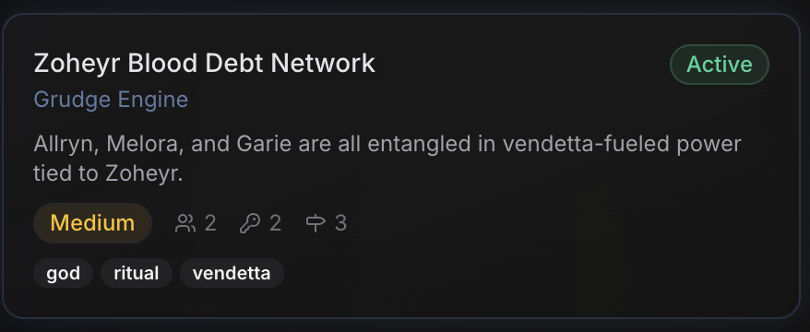remove the blue subtitles, what is the icon to the right of the key mean? Also remove the tags at the bottom
  - Specifically say “Low/Medium/High Priority”
- Timeline Events: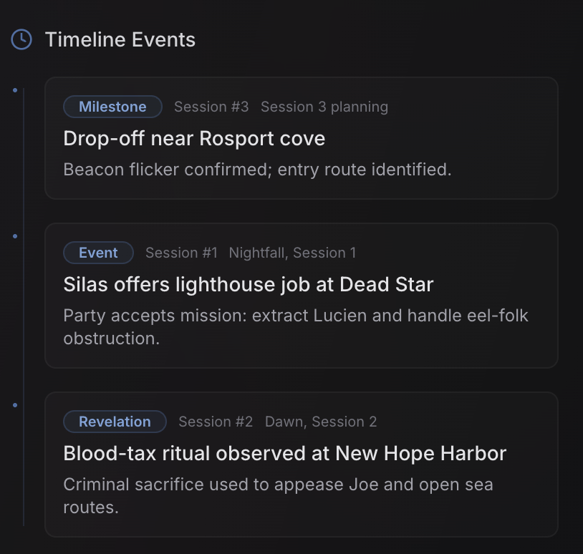only put which session each event happened in, i.e., remove “session 3 planning” for example
  - List which events are still active or in the future or completed
- Connected Secrets: 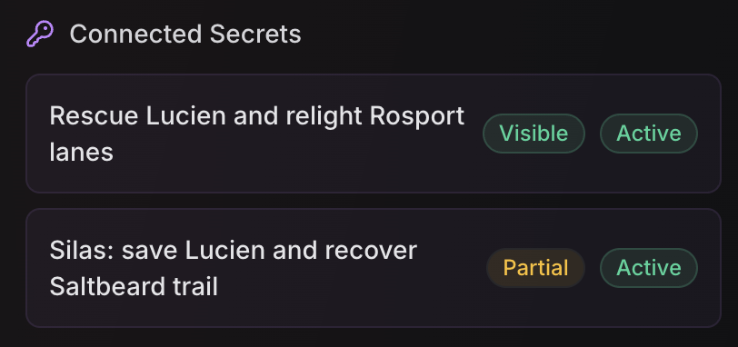remove “active” and replace “visible / partial” with “known / unknown”
- Move DM notes to top
- NPC Tracker:
  - under NPC name put
    - Race/species:
    - Class:
    - Age:
    - physical appearance description
  - Under goals put leverages and weaknesses sections
  - 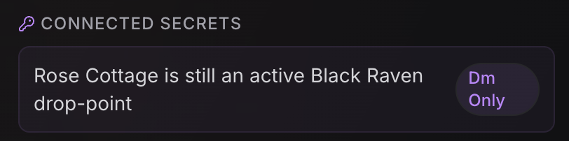remove
  - Change “sessions” to “session appearances”
- Secrets & Goals:

